CARTWRIGHTS CORNER

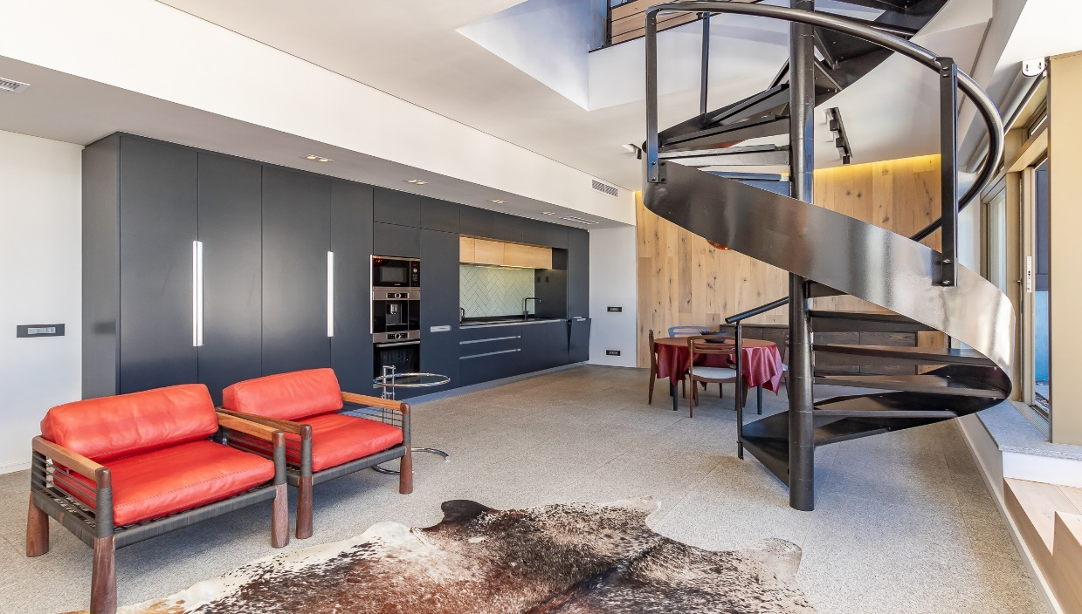

2304

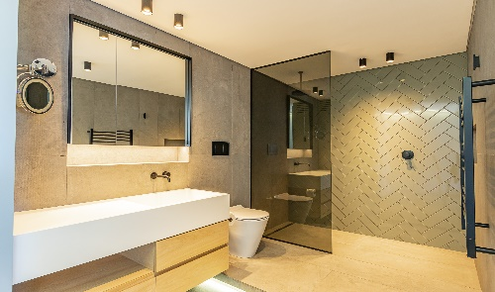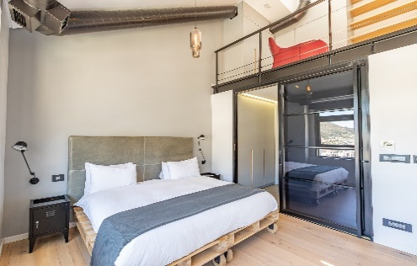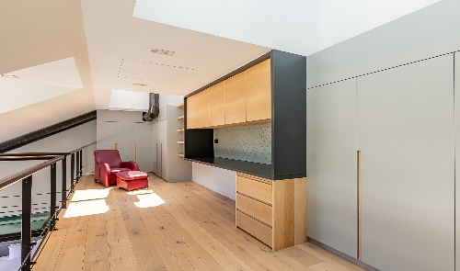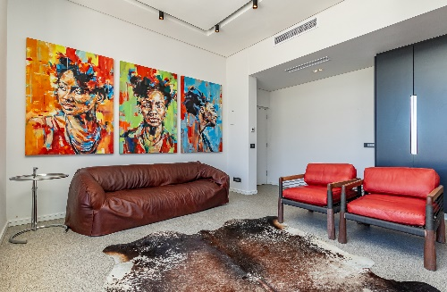[](http://www.google.co.za/url?sa=i&rct=j&q=&esrc=s&source=images&cd=&cad=rja&uact=8&ved=0ahUKEwijvMPZosjOAhWJ1BoKHVmrAF0QjRwIBw&url=http://www.southafricaexplorer.co.za/articles/tourism-grading-council.html&psig=AFQjCNHBYrMpuTK9XkzPDBeBifgz5SvN7w&ust=1471517128656589)[](http://www.google.co.za/url?sa=i&rct=j&q=&esrc=s&source=images&cd=&cad=rja&uact=8&ved=0ahUKEwiEoqvSo8jOAhUMChoKHY5fBAAQjRwIBw&url=http://vaaltriangle.harcourts.co.za/Home/Legal/Estate-Agents-Affairs-Board/37172&bvm=bv.129759880,d.ZGg&psig=AFQjCNHISSNutcCHUWiNWB4F6Jjklecukw&ust=1471517354060905)

**DESCRIPTION:** One Bedroom, Two bathroom Apartment

**VIEWS:** This apartment is situated on the 23rd floor of the Cartwrights Corner building with views of Table Mountain, Parlaiment and the Companje gardens.

**SLEEPS:** Sleeps 2 (1 x Super King bed)

**AUDIO:** Smart Apple TV, with Netflix

**AIR-CONDITIONING:** Central heating and cooling (Bedroom and lounge)

**INTERNET:** Complimentary Uncapped Wi-Fi

**PARKING:** Secured, assigned parking bay within building

**ADDITIONAL SERVICES & FEATURES INCLUDE:**

The apartment offers: Dining room table - seats 4, Microwave, hob/oven, washer/dryer combination, Selection of cooking utensils and cutlery, The building offers: 24/7 Staffed front desk, 24-hour security, Indoor swimming pool, Well-equipped gym. ITC provides housekeeping services, concierge services, 24 hours on call contact number, Premium linen, and towels.

**ATTRACTIONS** Cartwright’s Corner is centrally located within the CBD. Museums, open-air arts-and-crafts markets, shopping, and restaurants are only a couple options within walking distance from this beautiful building.

The V&A Waterfront is within walking distance, including the CTICC and financial district.

**TRANSPORT** The My city bus offers airport transfers and a safe commute option available in Cape Town. The Airport is approximately 20 minutes away from Cartwright’s corner.